**INTE 11223 – Programming Concepts**

GROUP PROJECT

Submitted by: Group 10

IM/2018/010

IM/2018/020

IM/2018/025

IM/2018/035

IM/2018/059

IM/2018/061

Lecturer:

Mr. Janaka Wijayanayake

BSc.(Hons) in Management and Information Technology

Department of Industrial Management

Faculty of Science

University of Kelaniya

August 19, 2020

**2048 game**

**Introduction**

2048 is a single player game played on a 4×4 grid. The objective of the game is to slide numbered tiles on a grid to combine them to create a tile with the number 2048.

**How to play**

The numbered tiles slide when a player moves them using the four arrow keys. Every turn, a new tile will randomly appear in an empty spot on the board with a value of 2. Tiles slide as far as possible in the chosen direction until they are stopped by either another tile or the edge of the grid. If two tiles of the same number collide while moving, they will merge into a tile with the total value of the two tiles that collided.  The resulting tile cannot merge with another tile again in the same move.

If a move causes three consecutive tiles of the same value to slide together, only the two tiles farthest along the direction of motion will combine. If all four spaces in a row or column are filled with tiles of the same value, a move parallel to that row/column will combine the first two and last two.

**Game play**

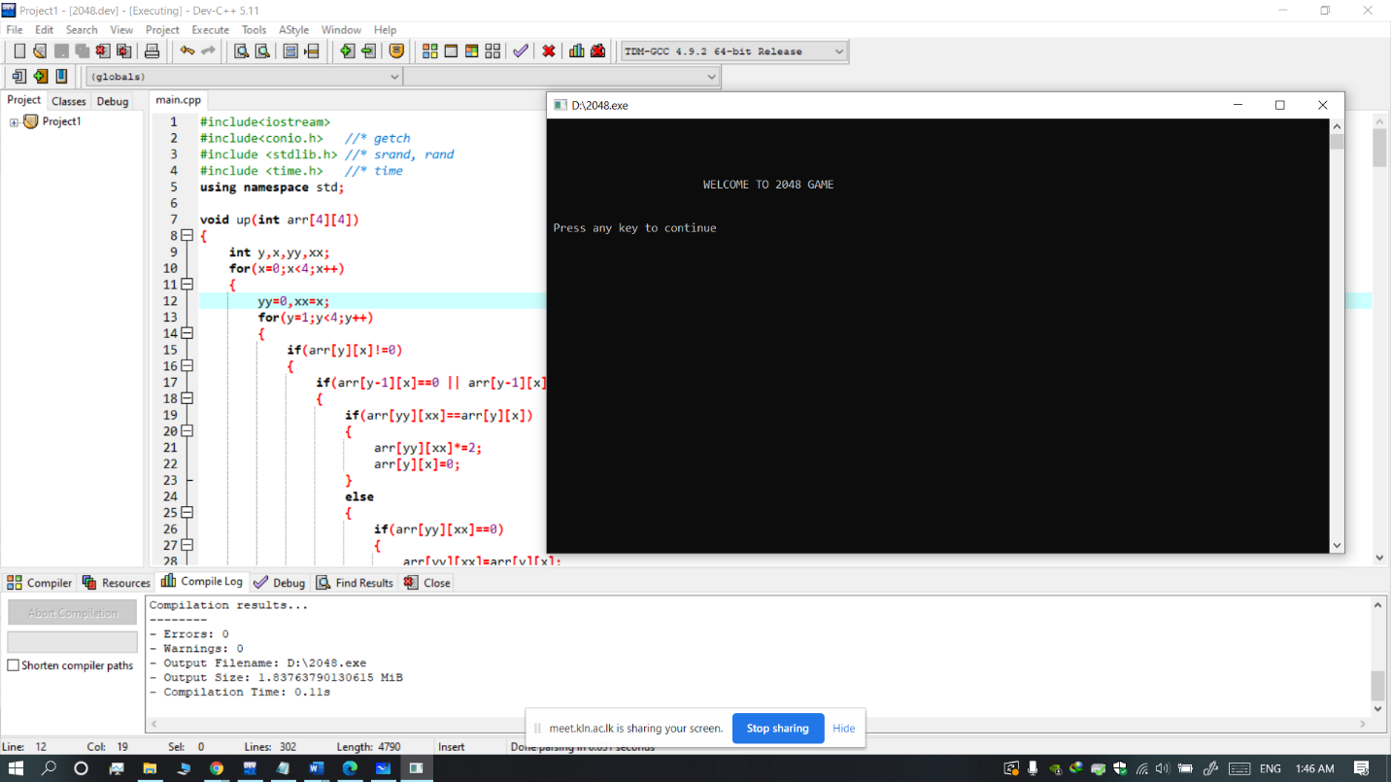

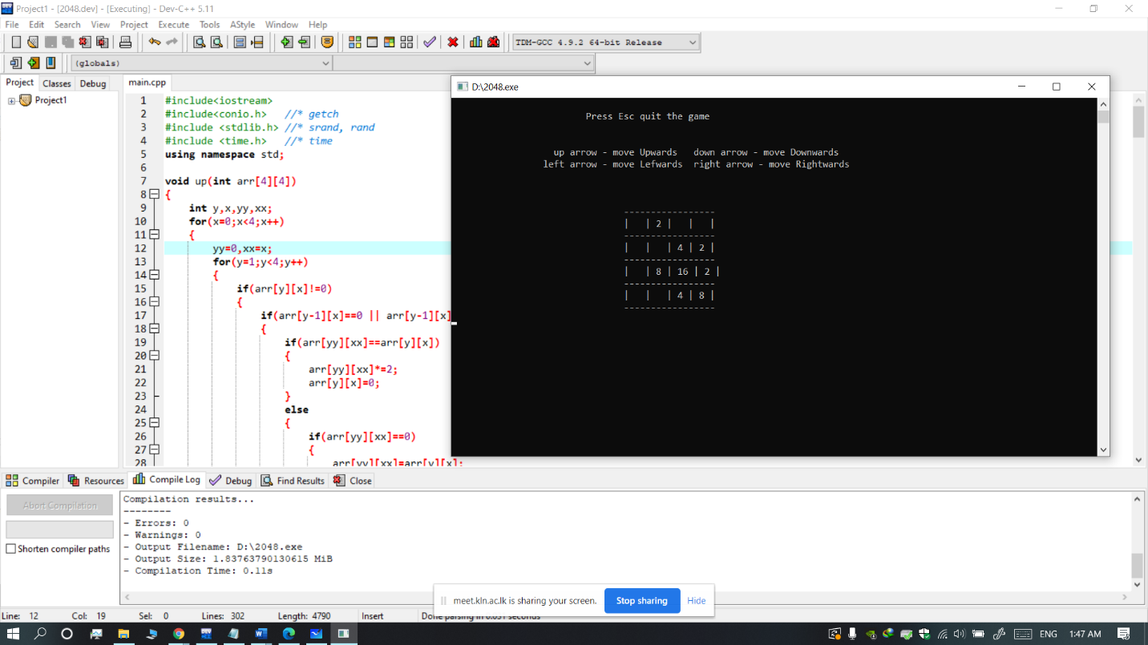

**Strategy**

In general, most players will keep the tile with the highest value in the corner. They then add tiles sliding into the biggest tile to make higher tiles.

**Problems and challenges**

* There were no talented members in programming.
* We had to go through many tutorials and videos.
* There were many design ideas with the group members. So selecting the best design was a challenge for us.
* There were difficulties in contacting the group members due to connection errors.
* We had to search for different areas in programming.
* We got many compile errors. So, we spent time to correct them.
* For different functions, we had to use different libraries. So we had to search and go through them.
* We were unable to study more about the graphic functions because of the limited time duration.
* Some group members were unable to run graphic files because of their compiler issues.
* Using visual basic is easier but some members were not able to download it because of the file size.

**How can we improve the game**

* We can use more code libraries to develop this game.
* We can use graphics and make it more eye catching by using graphics.
* Adding blinkings and colour reductions from dark to light of the tiles according to descending order of the values and score boards can be used to develop this game.
* We can develop it to a level by level game.
* We can wide the number of rows and columns in the grid and can develop it by changing the sequence of the numbers.

**Game code**

#include<iostream>

#include<conio.h> //* getch

#include <stdlib.h> //* srand, rand

#include <time.h> //* time

using namespace std;

void up(int arr[4][4])

{

int y,x,yy,xx;

for(x=0;x<4;x++)

{

yy=0,xx=x;

for(y=1;y<4;y++)

{

if(arr[y][x]!=0)

{

if(arr[y-1][x]==0 || arr[y-1][x]==arr[y][x])

{

if(arr[yy][xx]==arr[y][x])

{

arr[yy][xx]*=2;

arr[y][x]=0;

}

else

{

if(arr[yy][xx]==0)

{

arr[yy][xx]=arr[y][x];

arr[y][x]=0;

}

else

{

arr[++yy][xx]=arr[y][x];

arr[y][x]=0;

}

}

}

else yy++;

}

}

}

}

void down(int arr[4][4])

{

int y,x,yy,xx;

for(x=0;x<4;x++)

{

yy=3,xx=x;

for(y=2;y>=0;y--)

{

if(arr[y][x]!=0)

{

if(arr[y+1][x]==0 || arr[y+1][x]==arr[y][x])

{

if(arr[yy][xx]==arr[y][x])

{

arr[yy][xx]*=2;

arr[y][x]=0;

}

else

{

if(arr[yy][xx]==0)

{

arr[yy][xx]=arr[y][x];

arr[y][x]=0;

}

else

{

arr[--yy][xx]=arr[y][x];

arr[y][x]=0;

}

}

}

else yy--;

}

}

}

}

void left(int arr[4][4])

{

int y,x,yy,xx;

for(y=0;y<4;y++)

{

yy=y,xx=0;

for(x=1;x<4;x++)

{

if(arr[y][x]!=0)

{

if(arr[y][x-1]==0 || arr[y][x-1]==arr[y][x])

{

if(arr[yy][xx]==arr[y][x])

{

arr[yy][xx]*=2;

arr[y][x]=0;

}

else

{

if(arr[yy][xx]==0)

{

arr[yy][xx]=arr[y][x];

arr[y][x]=0;

}

else

{

arr[yy][++xx]=arr[y][x];

arr[y][x]=0;

}

}

}

else xx++;

}

}

}

}

void right(int arr[4][4])

{

int y,x,yy,xx;

for(y=0;y<4;y++)

{

yy=y,xx=3;

for(x=2;x>=0;x--)

{

if(arr[y][x]!=0)

{

if(arr[y][x+1]==0 || arr[y][x+1]==arr[y][x])

{

if(arr[yy][xx]==arr[y][x])

{

arr[yy][xx]*=2;

arr[y][x]=0;

}

else

{

if(arr[yy][xx]==0)

{

arr[yy][xx]=arr[y][x];

arr[y][x]=0;

}

else

{

arr[yy][--xx]=arr[y][x];

arr[y][x]=0;

}

}

}

else xx--;

}

}

}

}

void newnumber(int arr[4][4])

{

int yy,xx;

srand(time(0));

while(1)

{

yy=rand()%4;

xx=rand()%4;

if(arr[yy][xx]==0)

{

arr[yy][xx]=2;

break;

}

}

}

void instruct(int arr[4][4])

{

cout<<"\n\t\t\t Press Esc quit the game\n\n";

cout<<"\n\t\t up arrow - move Upwards down arrow - move Downwards";

cout<<"\n\t\t left arrow - move Lefwards right arrow - move Rightwards";

cout<<"\n\n\n\n";

int i,j;

for(i=0;i<4;i++)

{

cout<<"\t\t\t\t-----------------\n\t\t\t\t";

for(j=0;j<4;j++)

{

if(arr[i][j]==0) cout<<"| ";

else

cout<<"| "<<arr[i][j]<<" ";

}

cout<<"|"<<endl;

}

cout<<"\t\t\t\t-----------------\n";

}

int checknum(int tmp[4][4],int arr[4][4])

{

int rt=1,i,j;

for(i=0;i<4;i++)

for(j=0;j<4;j++)

if(tmp[i][j]!=arr[i][j])

{

rt=0;

break;

}

return rt;

}

int checkwin(int arr[4][4])

{

int i,j;

for(i=0;i<4;i++)

for(j=0;j<4;j++)

if(arr[i][j] == 2048)

{

return 1;

}

return 0;

}

int gameover(int arr[4][4])

{

int f=0,g=0,i,j;

for(i=0;i<4;i++)

for(j=0;j<4;j++)

if(arr[i][j]==0)

{

f=1;

break;

}

for(i=0;i<3;i++)

for(j=0;j<3;j++)

if(arr[i+1][j]==arr[i][j] || arr[i][j+1]==arr[i][j])

{

g=1;

break;

}

if(f || g) return 1;

else return 0;

}

int main()

{

cout<<"\n\n\n\n\t\t\tWELCOME TO 2048 GAME\n\n\n Press any key to continue";

getch();

system("cls"); //*Clear Screen

int x,y,i,j;

int arr[4][4]={0},tmp[4][4]={0};

srand(time(0));

x=rand()%4;

y=rand()%4;

arr[x][y]=2;

instruct(arr);

int ch;

while (1)

{

for(i=0;i<4;i++)

for(j=0;j<4;j++)

tmp[i][j]=arr[i][j];

ch=getch();

system("cls");

if(ch==72) up(arr); //* In ASCII decimal 72 for up arrow key

if(ch==80) down(arr); //* In ASCII decimal 80 for down arrow key

if(ch==75) left(arr); //* In ASCII decimal 75 for left arrow key

if(ch==77) right(arr); //* In ASCII decimal 77 for right arrow key

if(ch==27) break; //* In ASCII decimal 27 for Escape Key

if(!checknum(tmp,arr))

newnumber(arr);

instruct(arr);

if (checkwin(arr))

{

cout<<"\n\n\t\t\t\t YOU WON THE GAME"<<endl;

getch();

break;

}

if(!gameover(arr))

{

cout<<"\n\n\t\t\tGAME OVER!!\n\n\n";

getch();

break;

}

}

return 0;

}